Solution and Answer Guide
Camm/Cochran/Fry/Ohlmann/Anderson/Sweeney/Williams, Essentials of Modern Business Statistics w/MS Excel 9th Edition, 9780357984505; Chapter 1: Data and Statistics
Table of Contents
Supplementary Exercises 1

Supplementary Exercises
1. Wall Street Journal Subscriber Characteristics. A Wall Street Journal subscriber survey asked 46 questions about subscriber characteristics and interests. State whether each of the following questions provides categorical or quantitative data. LO 2
a. What is your age?
b. Are you married?
c. When did you first start reading the WSJ? High school, college, early career, midcareer, late career, or retirement?
d. How long have you been in your present job or position?
e. What type of vehicle are you considering for your next purchase? Nine response categories include sedan, sports car, SUV, minivan, and so on.
Solutions:
a. Quantitative
b. Categorical
c. Categorical
d. Quantitative
e. Categorical
2. Comparing Tablet Computers. Tablet PC Comparison provides a wide variety of information about tablet computers. Their website enables consumers to easily compare different tablets using factors such as cost, type of operating system, display size, battery life, and CPU manufacturer. A sample of 10 tablet computers is shown in Table 1.6 (Tablet PC Comparison website). LO 1, 2
Table 1.6 Product Information for 10 Tablet Computers
Tablet | Cost ($) | Operating System | Display Size (inches) | Battery Life (hours) | CPU Manufacturer
Acer Iconia W510 | 599 | Windows | 10.1 | 8.5 | Intel
Amazon Kindle Fire HD | 299 | Android | 8.9 | 9.0 | TI OMAP
Apple iPad 4 | 499 | iOS | 9.7 | 11.0 | Apple
HP Envy X2 | 860 | Windows | 11.6 | 8.0 | Intel
Lenovo ThinkPad Tablet | 668 | Windows | 10.1 | 10.5 | Intel
Microsoft Surface Pro | 899 | Windows | 10.6 | 4.0 | Intel
Motorola Droid XYboard | 530 | Android | 10.1 | 9.0 | TI OMAP
Samsung Ativ Smart PC | 590 | Windows | 11.6 | 7.0 | Intel
Samsung Galaxy Tab | 525 | Android | 10.1 | 10.0 | Nvidia
Sony Tablet S | 360 | Android | 9.4 | 8.0 | Nvidia
a. How many elements are in this data set?
b. How many variables are in this data set?
c. Which variables are categorical and which variables are quantitative?
d. What type of measurement scale is used for each of the variables?
Solutions:
a. The 10 elements are the 10 tablet computers.
b. Five variables: Cost ($), Operating System, Display Size (inches), Battery Life (hours), CPU Manufacturer
c. Categorical variables: Operating System and CPU Manufacturer
Quantitative variables: Cost ($), Display Size (inches), and Battery Life (hours)
d.
Variable | Measurement Scale
Cost ($) | Ratio
Operating System | Nominal
Display Size (inches) | Ratio
Battery Life (hours) | Ratio
CPU Manufacturer | Nominal
3. Tablet PCs: Cost, CPU, and Operating System. Refer to Table 1.6. LO 3
a. What is the average cost for the tablets?
b. Compare the average cost of tablets with a Windows operating system to the average cost of tablets with an Android operating system.
c. What percentage of tablets use a CPU manufactured by TI OMAP?
d. What percentage of tablets use an Android operating system?
Solutions:
a. Average cost = 5,829/10 = $582.90
b. Average cost with a Windows operating system = 3,616/5 = $723.20
Average cost with an Android operating system = 1,714/4 = $428.5
The average cost with a Windows operating system is much higher.
c. 2 of 10 or 20% use a CPU manufactured by TI OMAP.
d. 4 of 10 or 40% use an Android operating system.
4. Comparing Phones. Table 1.7 shows data for eight phones (Consumer Reports). The Overall Score, a measure of the overall quality for the phone, ranges from 0 to 100. Voice Quality has possible ratings of poor, fair, good, very good, and excellent. Talk Time is the manufacturer’s claim of how long the phone can be used when it is fully charged. LO 1, 2
Table 1.7 Data for Eight Phones
Brand | Model | Price ($) | Overall Score | Voice Quality | Talk Time (hours)
AT&T | CL84100 | 60 | 73 | Excellent | 7
AT&T | TL92271 | 80 | 70 | Very Good | 7
Panasonic | 4773B | 100 | 78 | Very Good | 13
Panasonic | 6592T | 70 | 72 | Very Good | 13
Uniden | D2997 | 45 | 70 | Very Good | 10
Uniden | D1788 | 80 | 73 | Very Good | 7
Vtech | DS6521 | 60 | 72 | Excellent | 7
Vtech | CS6649 | 50 | 72 | Very Good | 7
a. How many elements are in this data set?
b. For the variables Price, Overall Score, Voice Quality, and Talk Time, which variables are categorical and which variables are quantitative?
c. What scale of measurement is used for each variable?
Solutions:
a. There are eight elements in this data set; each element corresponds to one of the eight models of cordless telephones.
b. Categorical variables: Voice Quality and Handset on Base
Quantitative variables: Price, Overall Score, and Talk Time
c. Price – ratio measurement
Overall Score – interval measurement
Voice Quality – ordinal measurement
Handset on Base – nominal measurement
Talk Time – ratio measurement
5. Summarizing Phone Data. Refer to the data set in Table 1.7. LO 3
a. What is the average price for the phones?
b. What is the average talk time for the phones?
c. What percentage of the phones have a voice quality of excellent?
Solutions:
a. Average Price = 545/8 = $68.13
b. Average Talk Time = 71/8 = 8.875 hours
c. Percentage rated Excellent: 2 of 8 2/8 = 0.25, or 25%
6. New Automobile Owners Survey. J.D. Power and Associates surveys new automobile owners to learn about the quality of recently purchased vehicles. The following questions were asked in the J.D. Power Initial Quality Survey. Comment on whether each of the following questions provides categorical or quantitative data. LO 2
a. Did you purchase or lease the vehicle?
b. What price did you pay?
c. What is the overall attractiveness of your vehicle’s exterior? (Unacceptable, Average, Outstanding, or Truly Exceptional)
d. What is your average number of miles per gallon?
e. What is your overall rating of your new vehicle? (l- to 10-point scale with
1 Unacceptable and 10 Truly Exceptional)
Solutions:
a. Categorical
b. Quantitative
c. Categorical
d. Quantitative
e. Quantitative
7. Airline Customer Satisfaction. Many service companies collect data via a follow-up survey of their customers. For example, to ascertain customer sentiment, Delta Air Lines sends an e-mail to customers immediately following a flight. Among other questions, Delta asks:
How likely are you to recommend Delta Air Lines to others?
The possible responses are:
Definitely | Probably | May or May | Probably Will | Definitely Will
Will | Will | Not | Not | Not
❍ | ❍ | ❍ | ❍ | ❍
Use this information to answer the following questions. LO 2, 4
a. Are the data collected by Delta in this example quantitative or categorical?
b. What measurement scale is used?
Solutions:
a. Since there are five choices, the response is a categorical response.
b. The five responses are the labels for the customer responses. A nominal scale is being used.
8. Readership Poll. The Tennessean, an online newspaper located in Nashville, Tennessee, conducts a daily poll to obtain reader opinions on a variety of current issues. In a recent poll, 762 readers responded to the following question: “If a constitutional amendment to ban a state income tax is placed on the ballot in Tennessee, would you want it to pass?” Possible responses were Yes, No, or Not Sure (The Tennessean website). LO 1, 2, 3
a. What was the sample size for this poll?
b. Are the data categorical or quantitative?
c. Would it make more sense to use averages or percentages as a summary of the data for this question?
d. Of the respondents, 67% said Yes, they would want it to pass. How many individuals provided this response?
Solutions:
a. 762
b. Categorical
c. Percentages
d. 0.67(762) = 510.54
510 or 511 respondents said they want the amendment to pass.
9. College-Educated Workers. Based on data from the U.S. Census Bureau, a Pew Research study showed that the percentage of employed individuals ages 25–29 who are college educated is at an all-time high. The study showed that the percentage of employed individuals aged 25–29 with at least a bachelor’s degree in 2016 was 40%. In the year 2000, this percentage was 32%, in 1985 it was 25%, and in 1964 it was only 16% (Pew Research website). LO 4
a. What is the population being studied in each of the four years in which Pew has data?
b. What question was posed to each respondent?
c. Do responses to the question provide categorical or quantitative data?
Solutions:
a. The population is employed individuals in the United States aged 25–29.
b. Have you earned a bachelor’s degree (or higher)?
c. Since the response is yes or no, the response is categorical.
10. Driving with Cell Phones. The Bureau of Transportation Statistics Omnibus Household Survey is conducted annually and serves as an information source for the U.S. Department of Transportation. In one part of the survey the person being interviewed was asked to respond to the following statement: “Drivers of motor vehicles should be allowed to talk on a handheld cell phone while driving.” Possible responses were strongly agree, somewhat agree, somewhat disagree, and strongly disagree. Forty-four respondents said that they strongly agree with this statement, 130 said that they somewhat agree, 165 said they somewhat disagree, and 741 said they strongly disagree with this statement (Bureau of Transportation website). LO 2, 3
a. Do the responses for this statement provide categorical or quantitative data?
b. Would it make more sense to use averages or percentages as a summary of the responses for this statement?
c. What percentage of respondents strongly agree with allowing drivers of motor vehicles to talk on a handheld cell phone while driving?
d. Do the results indicate general support for or against allowing drivers of motor vehicles to talk on a handheld cell phone while driving?
Solutions:
a. Categorical
b. Percentages
c. 44 of 1,080 respondents or approximately 4% strongly agree with allowing drivers of motor vehicles to talk on a handheld cell phone while driving.
d. 165 of the 1,080 respondents or 15% of said they somewhat disagree and 741 or 69% said they strongly disagree. Thus, there does not appear to be general support for allowing drivers of motor vehicles to talk on a handheld cell phone while driving.
11. Driverless Cars Expected Soon. A Gallup Poll utilizing a random sample of 1,503 adults ages 18 or older was conducted in April 2018. The survey indicated a majority of Americans (53%) say driverless cars will be common in the next 10 years (Gallup, The question asked was:
Thinking about fully automated, “driverless cars,” cars that use technology to drive and do not need a human driver, based on what you have heard or read, how soon do you think driverless cars will be commonly used in the [United States]?
Figure 1.10 shows a summary of results of the survey in a histogram indicating the percentage of the total responses in different time intervals. LO 2, 3
FIGURE 1.10 Histogram of Survey Results on Driverless Cars
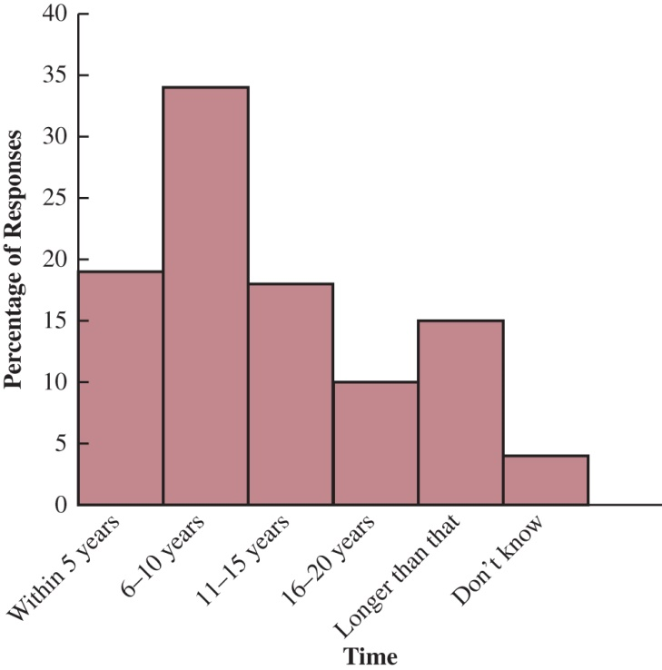
a. Are the responses to the survey question quantitative or categorical?
b. How many of the respondents said that they expect driverless cars to be common in the next 10 years?
c. How many respondents answered in the range 16–20 years?
Solutions:
a. Since the respondents answer with some time interval, the response is categorical.
b. 0.53(1,503) = 796.59 or approximately 797
c. 0.10(1,503) = 150.3 or approximately 150
12. Hawaii Visitors Poll. The Hawaii Visitors Bureau collects data on visitors to Hawaii. The following questions were among 16 asked in a questionnaire handed out to passengers during incoming airline flights.
- This trip to Hawaii is my: 1st, 2nd, 3rd, 4th, etc.
- The primary reason for this trip is: (10 categories, including vacation, convention, honeymoon)
- Where I plan to stay: (11 categories, including hotel, apartment, relatives, camping)
- Total days in Hawaii
Use this information to answer the following questions. LO 2, 4
a. What is the population being studied?
b. Is the use of a questionnaire a good way to reach the population of passengers on incoming airline flights?
c. Comment on each of the four questions in terms of whether it will provide categorical or quantitative data.
Solutions:
a. The population is all visitors coming to the state of Hawaii.
b. Since airline flights carry the vast majority of visitors to the state, the use of questionnaires for passengers during incoming flights is a good way to reach this population. The questionnaire actually appears on the back of a mandatory plants and animals declaration form that passengers must complete during the incoming flight. A large percentage of passengers complete the visitor information questionnaire.
c. Questions one and four provide quantitative data indicating the number of visits and the number of days in Hawaii. Questions two and three provide categorical data indicating the categories of reason for the trip and where the visitor plans to stay.
13. Netflix Subscribers. Figure 1.11 provides a bar chart showing the number of Netflix subscribers from 2011 to 2020 (nscreenmedia.com). LO 1, 2
a. What is the variable of interest?
b. Are the data categorical or quantitative?
c. Are the data time series or cross-sectional?
d. Comment on the trend in Facebook’s annual advertising revenue over time.
FIGURE 1.11 Netflix Subscribers (millions)
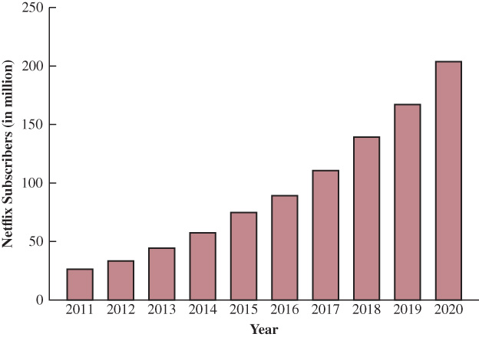
Solutions:
a. Number of Netflix subscribers
b. Quantitative
c. Time series
d. The number of Netflix subscribers is increasing at an increasing rate over time.
14. Rental Car Fleet Size. The following data show the number of rental cars in service for three rental car companies: Hertz, Avis, and Dollar, over a four-year period. LO 2
Cars in Service (1,000s)
Company | Year 1 | Year 2 | Year 3 | Year 4
Hertz | 327 | 311 | 286 | 290
Dollar | 167 | 140 | 106 | 108
Avis | 204 | 220 | 300 | 270
a. Construct a time series graph for the years 1 to 4 showing the number of rental cars in service for each company. Show the time series for all three companies on the same graph.
b. Comment on who appears to be the market share leader and how the market shares are changing over time.
c. Construct a bar chart showing rental cars in service for year 4. Is this chart based on cross-sectional or time series data?
Solutions:
a. The graph of the time series follows:

b. In year 1 and year 2 Hertz was the clear market share leader. In year 3 and year 4 Hertz and Avis have approximately the same market share. The market share for Dollar appears to be declining.
c. The bar chart for year 4 is shown below.

This chart is based on cross-sectional data.
15. Worldwide Robot Supply. The International Federation of Robotics estimates the worldwide supply of industrial robots each year. Figure 1.12 shows estimates of the worldwide supply of industrial robots for the years 2015 to 2021. LO 1, 2
Figure 1.12 Estimated Industrial Robot Supply (1,000s units)
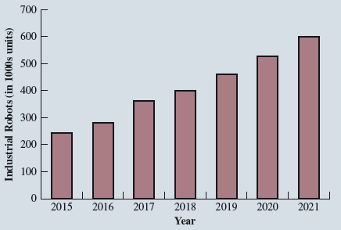
a. What is the variable of interest?
b. Are the data quantitative or categorical?
c. Are the data cross-sectional or time series?
Solutions:
a. Estimated supply of industrial robots worldwide
b. Quantitative
c. Time series
16. Athletic Shoe Sales. Sketchers U.S.A., Inc., is a performance footwear company headquartered in Manhattan Beach, California. The sales revenue for Sketchers over a
four-year period are as follows:
Year | Sales ($ billions)
Year 1 | 2.30
Year 2 | 3.15
Year 3 | 3.56
Year 4 | 4.16
Use this information to answer the following questions. LO 2, 3
a. Are these cross-sectional or time-series data?
b. Construct a bar graph similar to Figure 1.12.
c. What can you say about how Sketchers’ sales are changing over these four years?
Solutions:
a. Time series
b.

c. Sales appear to be increasing in a linear fashion.
17. Deciding on a Salary Increase. A manager of a large corporation recommends a $10,000 raise be given to keep a valued subordinate from moving to another company. What internal and external sources of data might be used to decide whether such a salary increase is appropriate? LO 5
Solutions:
Internal data on salaries of other employees can be obtained from the personnel department. External data might be obtained from the Department of Labor or industry associations.
18. Tax Survey. A random telephone survey of 1,021 adults (aged 18 and older) was conducted by Opinion Research Corporation on behalf of CompleteTax, an online tax preparation and e-filing service. The survey results showed that 684 of those surveyed planned to file their taxes electronically. LO 3
a. Develop a descriptive statistic that can be used to estimate the percentage of all taxpayers who file electronically.
b. The survey reported that the most frequently used method for preparing the tax return was to hire an accountant or professional tax preparer. If 60% of the people surveyed had their tax return prepared this way, how many people used an accountant or professional tax preparer?
c. Other methods that the person filing the return often used include manual preparation, use of an online tax service, and use of a software tax program. Would
the data for the method for preparing the tax return be considered categorical or quantitative?
Solutions:
a. 684/1,021; or approximately 67%
b. (0.6)*(1,021) = 612.6 Therefore, 612 or 613 used an accountant or professional tax preparer.
c. Categorical
19. Magazine Subscriber Survey. A Bloomberg Businessweek North American subscriber study collected data from a sample of 2,861 subscribers. Fifty-nine percent of the respondents indicated an annual income of $75,000 or more, and 50% reported having an American Express credit card. LO 2, 4, 5, 6
a. What is the population of interest in this study?
b. Is annual income a categorical or quantitative variable?
c. Is ownership of an American Express card a categorical or quantitative variable?
d. Does this study involve cross-sectional or time series data?
e. Describe any statistical inferences Bloomberg Businessweek might make on the basis of the survey.
Solutions:
a. All subscribers of Bloomberg Businessweek in North America at the time the survey was conducted.
b. Quantitative
c. Categorical (yes or no)
d. Cross-sectional—all the data relate to the same time.
e. Using the sample results, we could infer or estimate 59% of the population of subscribers have an annual income of $75,000 or more and 50% of the population of subscribers have an American Express credit card.
20. Investment Manager Survey. A survey of 131 investment managers in Barron’s Big Money poll revealed the following:
- Forty-three percent of managers classified themselves as bullish or very bullish on the stock market.
- The average expected return over the next 12 months for equities was 11.2%.
- Twenty-one percent selected health care as the sector most likely to lead the market in the next 12 months.
- When asked to estimate how long it would take for technology and telecom stocks to resume sustainable growth, the managers’ average response was 2.5 years.
Use this information to answer the following questions. LO 3, 7
a. Cite two descriptive statistics.
b. Make an inference about the population of all investment managers concerning the average return expected on equities over the next 12 months.
c. Make an inference about the length of time it will take for technology and telecom stocks to resume sustainable growth.
Solutions:
a. 43% of managers were bullish or very bullish.
21% of managers expected health care to be the leading industry over the next 12 months.
b. We estimate the average 12-month return estimate for the population of investment managers to be 11.2%.
c. We estimate the average over the population of investment managers to be 2.5 years.
21. Cancer Research. A seven-year medical research study reported that women whose mothers took the drug DES during pregnancy were twice as likely to develop tissue abnormalities that might lead to cancer as were women whose mothers did not take the drug. LO 3, 4, 5
a. This study compared two populations. What were the populations?
b. Do you suppose the data were obtained in a survey or an experiment?
c. For the population of women whose mothers took the drug DES during pregnancy, a sample of 3,980 women showed that 63 developed tissue abnormalities that might lead to cancer. Provide a descriptive statistic that could be used to
estimate the number of women out of 1,000 in this population who have tissue abnormalities.
d. For the population of women whose mothers did not take the drug DES during pregnancy, what is the estimate of the number of women out of 1,000 who would be expected to have tissue abnormalities?
e. Medical studies often use a relatively large sample (in this case, 3,980). Why?
Solutions:
a. The two populations are the population of women whose mothers took the drug DES during pregnancy and the population of women whose mothers did not take the drug DES during pregnancy.
b. It was a survey.
c. 63/3,980 = 0.0158 or 15.8 women out of each 1,000 developed tissue abnormalities.
d. The article reported “twice” as many abnormalities in the women whose mothers had taken DES during pregnancy. Thus, a rough estimate would be 15.8/2 = 7.9 abnormalities per 1,000 women whose mothers had not taken DES during pregnancy.
e. In many situations, disease occurrences are rare and affect only a small portion of the population. Large samples are needed to collect data on a reasonable number of cases where the disease exists.
22. Why People Move. A survey conducted by Better Homes and Gardens Real Estate LLC showed that one in five U.S. homeowners have either moved from their home or would like to move because their neighbourhood or community isn’t ideal for their lifestyle (Better Homes and Gardens Real Estate website). The top lifestyle priorities of respondents when searching for their next home include ease of commuting by car, access to health and safety services, family-friendly neighbourhood, availability of retail stores, access to cultural activities, public transportation access, and nightlife and restaurant access. Suppose a real estate agency in Denver, Colorado, hired you to conduct a similar study to determine the top lifestyle priorities for clients that currently have a home listed for sale with the agency or have hired the agency to help them locate a new home. LO 4, 5
a. What is the population for the survey you will be conducting?
b. How would you collect the data for this study?
Solutions:
a. The population consists of all clients that currently have a home listed for sale with the agency or have hired the agency to help them locate a new home.
b. Some of the ways that could be used to collect the data are as follows:
- A survey could be mailed to each of the agency’s clients.
- Each client could be sent an e-mail with a survey attached.
- The next time one of the firm’s agents meets with a client they could conduct a personal interview to obtain the data.
23. Investment in Cryptocurrency. Pew Research Center is a nonpartisan polling organization that provides information about issues, attitudes, and trends. In a poll of 10,371 adults in the United States, Pew found that 16% of those polled have used, invested in, or traded, digital currency known as cryptocurrency. Of those who responded to the poll, 22% of men and 10% of women indicated that they had used, invested in, or traded cryptocurrency. LO 4
a. To what population does the statistic 16% refer?
b. To what population does the statistic 10% refer?
c. Do you think Pew researchers conducted a census or took a sample to obtain their results? Explain your answer.
Solutions:
a. The population is all adults in the United States.
b. The population is all adult women in the United States.
c. Pew Research conducted a sample survey. It would not be practical to conduct a census because it would take too much time and money to do so.
24. Midterm Grades. A sample of midterm grades for five students showed the following results: 72, 65, 82, 90, 76. Which of the following statements are correct, and which should be challenged as being too generalized? LO 3, 4
a. The average midterm grade for the sample of five students is 77.
b. The average midterm grade for all students who took the exam is 77.
c. An estimate of the average midterm grade for all students who took the exam is 77.
d. More than half of the students who take this exam will score between 70 and 85.
e. If five other students are included in the sample, their grades will be between 65 and 90.
Solutions:
a. This is a statistically correct descriptive statistic for the sample.
b. An incorrect generalization since the data was not collected for the entire population.
c. An acceptable statistical inference based on the use of the word “estimate.”
d. While this statement is true for the sample, it is not a justifiable conclusion for the entire population.
e. This statement is not statistically supportable. While it is true for the particular sample observed, it is entirely possible and even very likely that at least some students will be outside the 65 to 90 range of grades.
25. Comparing Compact SUVs. Consumer Reports evaluates products for consumers. The file CompactSUV contains the data shown in Table 1.8 for 15 compact sports utility vehicles (SUVs) from the 2018 model line (Consumer Reports website):
Make—manufacturer
Model—name of the model
Table 1.8 Consumer Reports Data Set for 15 Compact Sports Utility Vehicles
Make | Model | Overall Score | Recommended | Owner Satisfaction | Overall Miles per Gallon | Acceleration (0–60) Sec
Subaru | Forester | 84 | Yes | + | 26 | 8.7
Honda | CRV | 83 | Yes | ++ | 27 | 8.6
Toyota | Rav4 | 81 | Yes | ++ | 24 | 9.3
Nissan | Rogue | 73 | Yes | + | 24 | 9.5
Mazda | CX-5 | 71 | Yes | ++ | 24 | 8.6
Kia | Sportage | 71 | Yes | + | 23 | 9.6
Ford | Escape | 69 | Yes | 0 | 23 | 10.1
Volkswagen | Tiguan Limited | 67 | No | 0 | 21 | 8.5
Volkswagen | Tiguan | 65 | No | + | 25 | 10.3
Mitsubishi | Outlander | 63 | No | 0 | 24 | 10.0
Chevrolet | Equinox | 63 | No | 0 | 31 | 10.1
Hyundai | Tucson | 57 | No | 0 | 26 | 8.4
GMC | Terrain | 57 | No | 0 | 22 | 7.2
Jeep | Cherokee | 55 | No | – | 22 | 10.9
Jeep | Compass | 50 | No | 0 | 24 | 9.8
Overall score—awarded based on a variety of measures, including those in this data set
Recommended—Consumer Reports recommends the vehicle or not
Owner satisfaction—satisfaction on a five-point scale based on the percentage of owners who would purchase the vehicle again (– –, –, 0, +, + +).
Overall miles per gallon—miles per gallon achieved in a 150-mile test trip
Acceleration (0–60 sec)—time in seconds it takes vehicle to reach 60 miles per hour from a standstill with the engine idling
Use these data to answer the following questions. LO 1, 2, 3
a. How many variables are in the data set?
b. Which of the variables are categorical, and which are quantitative?
c. What percentage of these 15 vehicles are recommended?
d. What is the average of the overall miles per gallon across all 15 vehicles?
Solutions:
a. There are five variables: Overall Score, Recommended, Owner Satisfaction, Overall Miles per Gallon, and Acceleration (0–60) Sec.
b. Categorical variables: Recommended, Owner Satisfaction
Quantitative variables: Overall Score, Overall Miles per Gallon, Acceleration (0–60) Sec
c. 7/15 or 47% are recommended.
d. 24.4 miles per gallon

